SELENIUM

---------

DAY9

---------

Drop Down

QUESTION 3

----------

URL : https://www.facebook.com/

NOTE: Print all the options in year using getAttirubute() method

package org.test;

import java.util.HashSet;

import java.util.List;

import java.util.Set;

//import java.util.List;

import org.openqa.selenium.By;

import org.openqa.selenium.WebDriver;

import org.openqa.selenium.WebElement;

import org.openqa.selenium.chrome.ChromeDriver;

import org.openqa.selenium.support.ui.Select;

public class JavaScript1 {

public static void main(String[] args) throws InterruptedException {

System.setProperty("webdriver.chrome.driver", "C:\\Users\\navee\\eclipse-workspace\\SeleniumJan09\\Driver\\chromedriver.exe");

WebDriver driver=new ChromeDriver();

driver.get("http://www.facebook.com/");

WebElement crt = driver.findElement(By.xpath("//a[text()='Create New Account']"));

crt.click();

Thread.sleep(3000);

WebElement mon = driver.findElement(By.id("year"));

Select s =new Select(mon);

List<WebElement> all = s.getOptions();

for (WebElement x : all) {

System.out.println(x.getAttribute("value"));

}

}

}

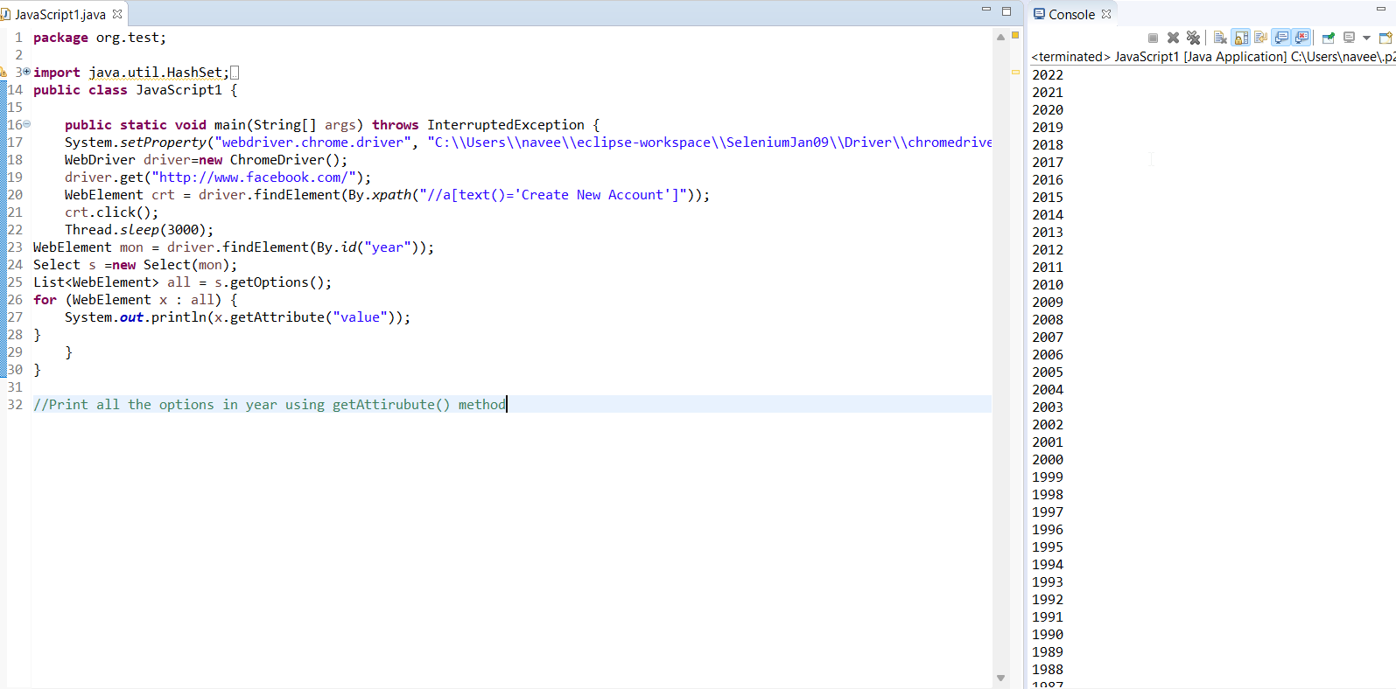

QUESTION 4

----------

URL : https://www.facebook.com/

NOTE: Print all the options in month using getText() method

**package** org.test;

**import** java.util.HashSet;

**import** java.util.List;

**import** java.util.Set;

//import java.util.List;

**import** org.openqa.selenium.By;

**import** org.openqa.selenium.WebDriver;

**import** org.openqa.selenium.WebElement;

**import** org.openqa.selenium.chrome.ChromeDriver;

**import** org.openqa.selenium.support.ui.Select;

**public** **class** JavaScript1 {

**public** **static** **void** main(String[] args) **throws** InterruptedException {

System.*setProperty*("webdriver.chrome.driver", "C:\\Users\\navee\\eclipse-workspace\\SeleniumJan09\\Driver\\chromedriver.exe");

WebDriver driver=**new** ChromeDriver();

driver.get("http://www.facebook.com/");

WebElement crt = driver.findElement(By.*xpath*("//a[text()='Create New Account']"));

crt.click();

Thread.*sleep*(3000);

WebElement mon = driver.findElement(By.*id*("month"));

Select s =**new** Select(mon);

List<WebElement> all = s.getOptions();

**int** size=all.size();

**for** (**int** i = 0; i < size; i++) {

WebElement opt = all.get(i);

System.***out***.println(all.get(i).getText());

}

}

}

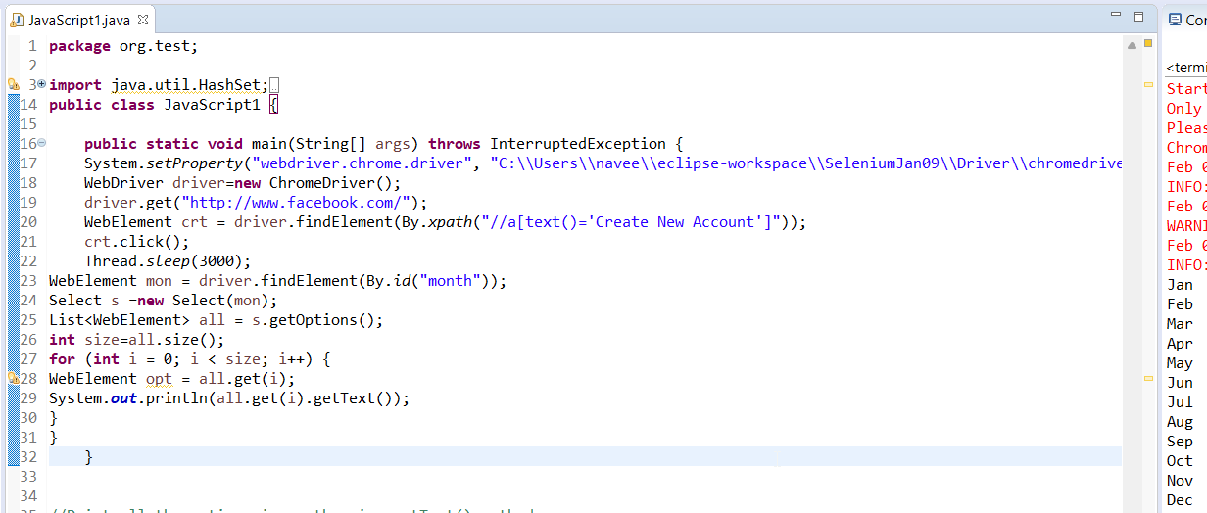

QUESTION 5

-----------

URL : https://www.facebook.com/

NOTE: print the even dates

**package** org.test;

**import** java.util.HashSet;

**import** java.util.List;

**import** java.util.Set;

//import java.util.List;

**import** org.openqa.selenium.By;

**import** org.openqa.selenium.WebDriver;

**import** org.openqa.selenium.WebElement;

**import** org.openqa.selenium.chrome.ChromeDriver;

**import** org.openqa.selenium.support.ui.Select;

**public** **class** JavaScript1 {

**public** **static** **void** main(String[] args) **throws** InterruptedException {

System.*setProperty*("webdriver.chrome.driver", "C:\\Users\\navee\\eclipse-workspace\\SeleniumJan09\\Driver\\chromedriver.exe");

WebDriver driver=**new** ChromeDriver();

driver.get("http://www.facebook.com/");

WebElement crt = driver.findElement(By.*xpath*("//a[text()='Create New Account']"));

crt.click();

Thread.*sleep*(3000);

WebElement mon = driver.findElement(By.*id*("day"));

Select s =**new** Select(mon);

List<WebElement> all = s.getOptions();

**int** size=all.size();

**for** (**int** i = 1; i < size; i++) {

**if**(i%2 == 1) {

WebElement opt = all.get(i);

System.***out***.println(all.get(i).getText());

}

}

}

}

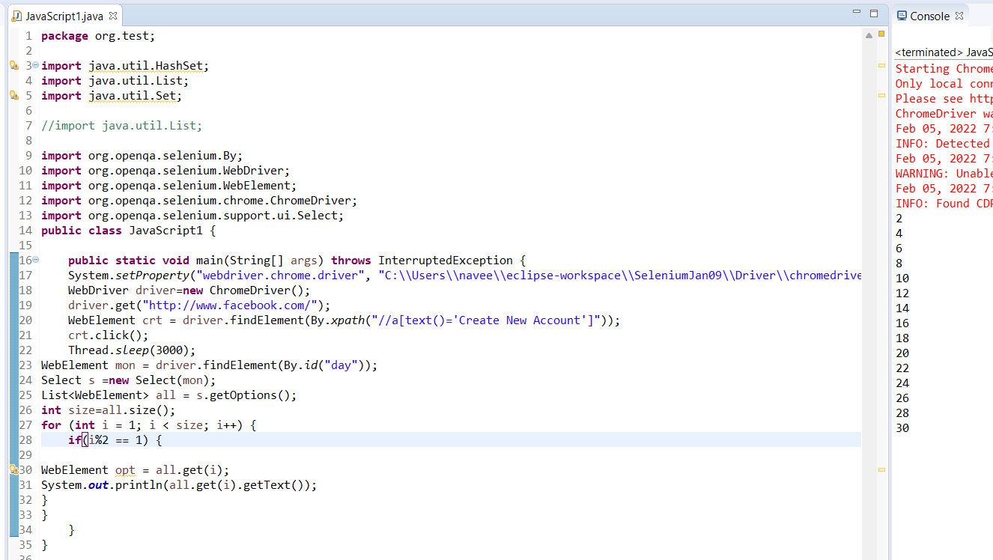

QUESTION 1

----------

URL : http://demoqa.com/automation-practice-form/

NOTE: print all the even option in State and City

**package** org.test;

**import** java.util.HashSet;

**import** java.util.List;

**import** java.util.Set;

//import java.util.List;

**import** org.openqa.selenium.By;

**import** org.openqa.selenium.WebDriver;

**import** org.openqa.selenium.WebElement;

**import** org.openqa.selenium.chrome.ChromeDriver;

**import** org.openqa.selenium.support.ui.Select;

**public** **class** JavaScript1 {

**public** **static** **void** main(String[] args) **throws** InterruptedException {

System.*setProperty*("webdriver.chrome.driver", "C:\\Users\\navee\\eclipse-workspace\\SeleniumJan09\\Driver\\chromedriver.exe");

WebDriver driver=**new** ChromeDriver();

driver.get("http://demoqa.com/automation-practice-form/");

WebElement crt = driver.findElement(By.*xpath*("(//div[@class=' css-1hwfws3'])[1]"));

//crt.click();

Thread.*sleep*(3000);

//WebElement mon = driver.findElement(By.id("day"));

Select s =**new** Select(crt);

List<WebElement> all = s.getOptions();

**int** size=all.size();

**for** (**int** i = 1; i < size; i++) {

**if**(i%2 == 1) {

WebElement opt = all.get(i);

System.***out***.println(all.get(i).getText());

}

}

}

}

QUESTION 6

-----------

URL : http://demo.guru99.com/test/newtours/register.php

NOTE: print all the option of country using getText() methods

**package** org.test;

**import** java.util.HashSet;

**import** java.util.List;

**import** java.util.Set;

//import java.util.List;

**import** org.openqa.selenium.By;

**import** org.openqa.selenium.WebDriver;

**import** org.openqa.selenium.WebElement;

**import** org.openqa.selenium.chrome.ChromeDriver;

**import** org.openqa.selenium.support.ui.Select;

**public** **class** JavaScript1 {

**public** **static** **void** main(String[] args) **throws** InterruptedException {

System.*setProperty*("webdriver.chrome.driver", "C:\\Users\\navee\\eclipse-workspace\\SeleniumJan09\\Driver\\chromedriver.exe");

WebDriver driver=**new** ChromeDriver();

driver.get("http://demo.guru99.com/test/newtours/register.php");

WebElement crt = driver.findElement(By.*name*("country"));

Thread.*sleep*(3000);

Select s =**new** Select(crt);

List<WebElement> all = s.getOptions();

**int** size=all.size();

**for** (**int** i = 0; i < size; i++) {

WebElement opt = all.get(i);

System.***out***.println(all.get(i).getText());

}

}

}

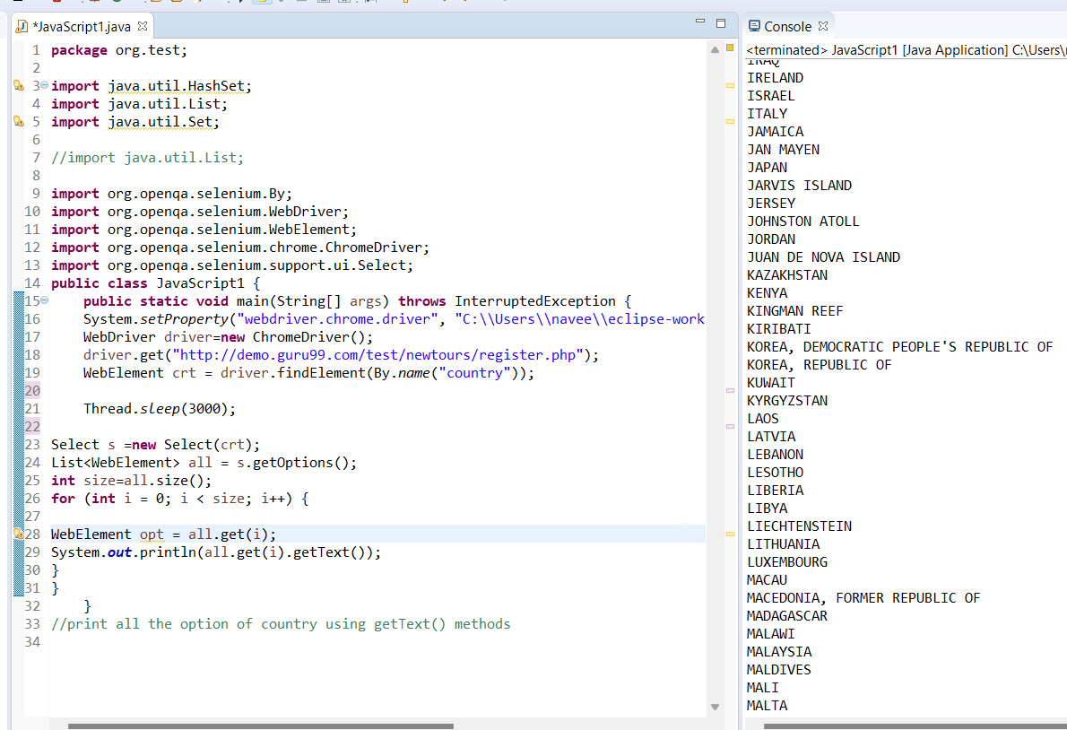

QUESTION 13

-----------

URL : http://output.jsbin.com/osebed/2

NOTE: Select All availble in fruits

Print first selected option

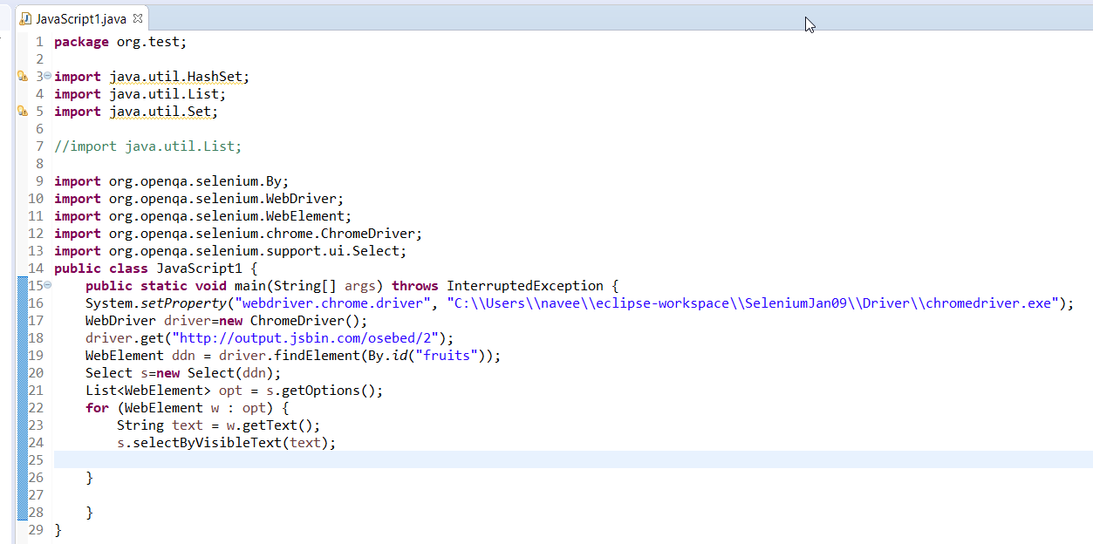

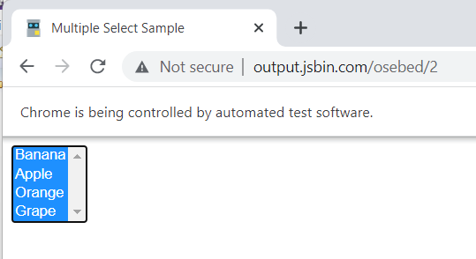

QUESTION 7

-----------

URL : http://demo.guru99.com/test/newtours/register.php

NOTE: print all the option of country using getAttribute() method

Register Form

**package** org.test;

**import** java.util.HashSet;

**import** java.util.List;

**import** java.util.Set;

//import java.util.List;

**import** org.openqa.selenium.By;

**import** org.openqa.selenium.WebDriver;

**import** org.openqa.selenium.WebElement;

**import** org.openqa.selenium.chrome.ChromeDriver;

**import** org.openqa.selenium.support.ui.Select;

**public** **class** JavaScript1 {

**public** **static** **void** main(String[] args) **throws** InterruptedException {

System.*setProperty*("webdriver.chrome.driver", "C:\\Users\\navee\\eclipse-workspace\\SeleniumJan09\\Driver\\chromedriver.exe");

WebDriver driver=**new** ChromeDriver();

driver.get("http://demo.guru99.com/test/newtours/register.php");

WebElement crt = driver.findElement(By.*name*("country"));

Thread.*sleep*(3000);

Select s =**new** Select(crt);

List<WebElement> all = s.getOptions();

**int** size=all.size();

**for** (WebElement web : all) {

System.***out***.println(web.getAttribute("value"));

}

}

}

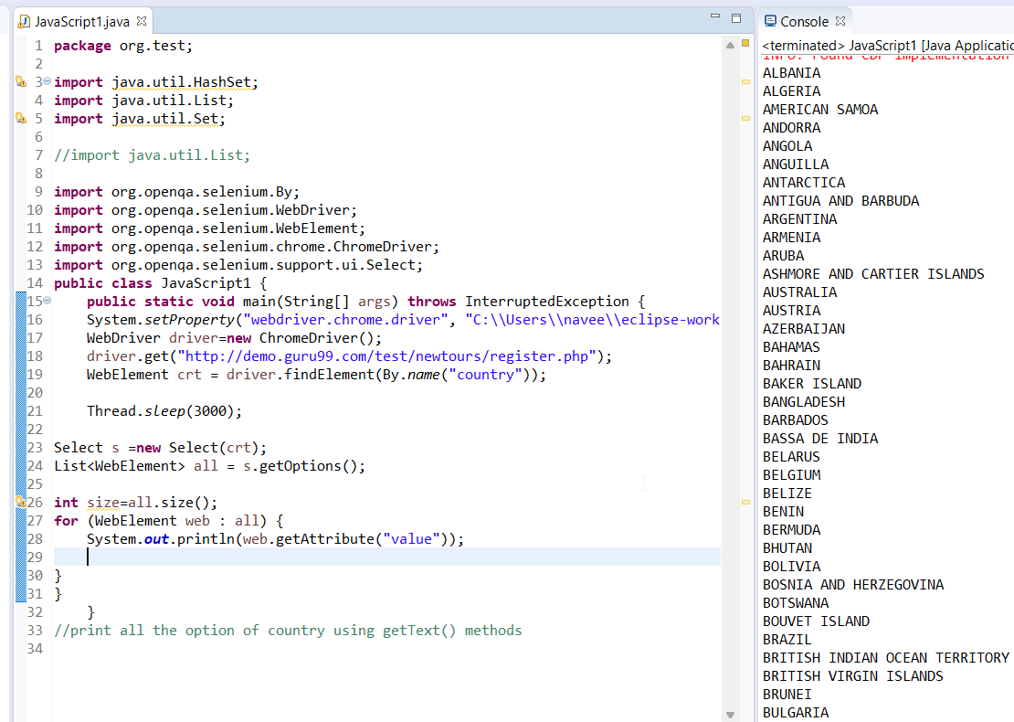

QUESTIONS(Practical)

--------------------

QUESTION 1

----------

URL : http://demoqa.com/automation-practice-form/

NOTE: print all the even option in State and City

QUESTION 2

----------

URL : http://demoqa.com/automation-practice-form/

NOTE: print all the odd option in State and City

QUESTION 3

----------

URL : https://www.facebook.com/

NOTE: Print all the options in year using getAttirubute() method

QUESTION 4

----------

URL : https://www.facebook.com/

NOTE: Print all the options in month using getText() method

QUESTION 5

-----------

URL : https://www.facebook.com/

NOTE: print the even dates

QUESTION 6

-----------

URL : http://demo.guru99.com/test/newtours/register.php

NOTE: print all the option of country using getText() methods

QUESTION 7

-----------

URL : http://demo.guru99.com/test/newtours/register.php

NOTE: print all the option of country using getAttribute() method

Register Form

QUESTION 8

------------

URL : http://adactinhotelapp.com/

NOTE: Book room and print order no.

**package** org.test;

**import** java.util.ArrayList;

**import** java.util.Collection;

**import** java.util.Collections;

**import** java.util.List;

**import** org.openqa.selenium.By;

**import** org.openqa.selenium.WebDriver;

**import** org.openqa.selenium.WebElement;

**import** org.openqa.selenium.chrome.ChromeDriver;

**import** org.openqa.selenium.support.ui.Select;

**public** **class** PracticeLA {

**public** **static** **void** main(String[] args) **throws** InterruptedException {

System.*setProperty*("webdriver.chrome.driver","C:\\Users\\navee\\OneDrive\\Desktop\\SeleniumPractice\\driver\\chromedriver.exe");

WebDriver driver =**new** ChromeDriver();

driver.get("http://adactin.com/HotelApp/");

driver.manage().window().maximize();

WebElement txtUserName = driver.findElement(By.*id*("username"));

txtUserName.sendKeys("NAVEENREDMI10");

WebElement txtPassword = driver.findElement(By.*id*("password"));

txtPassword.sendKeys("Adactin@123");

WebElement btnLogin= driver.findElement(By.*id*("login"));

btnLogin.click();

WebElement btnLocation = driver.findElement(By.*id*("location"));

Select s =**new** Select(btnLocation);

s.selectByIndex(5);

WebElement btnHotels = driver.findElement(By.*id*("hotels"));

Select s1=**new** Select(btnLocation);

s1.selectByIndex(5);

WebElement roomType = driver.findElement(By.*id*("room_type"));

Select s2=**new** Select(roomType);

s2.selectByIndex(3);

WebElement roomNos= driver.findElement(By.*id*("room_nos"));

Select s3=**new** Select(roomNos);

s3.selectByIndex(3);

WebElement checkIn= driver.findElement(By.*id*("datepick_in"));

checkIn.sendKeys("20/02/2022");

WebElement checkOut= driver.findElement(By.*id*("datepick_out"));

checkOut.sendKeys("20/02/2022");

WebElement adultPerRoom = driver.findElement(By.*id*("adult_room"));

Select s4 =**new** Select(adultPerRoom);

s.selectByIndex(2);

WebElement childPerRoom = driver.findElement(By.*id*("child_room"));

Select s5 =**new** Select(childPerRoom);

s.selectByIndex(1);

WebElement txtSearch = driver.findElement(By.*id*("Submit"));

txtSearch.click();

WebElement txtCheckBox = driver.findElement(By.*id*("radiobutton_1"));

txtCheckBox.click();

WebElement txtContinue= driver.findElement(By.*id*("continue"));

txtContinue.click();

WebElement txtFirstName= driver.findElement(By.*id*("first_name"));

txtFirstName.sendKeys("NAVEEN");

WebElement txtLastName= driver.findElement(By.*id*("last_name"));

txtLastName.sendKeys("kumar");

WebElement txtAddress= driver.findElement(By.*id*("address"));

txtAddress.sendKeys("16 EAST STREET");//

WebElement txtCcNo= driver.findElement(By.*id*("cc_num"));

txtCcNo.sendKeys("0123456789123456");

WebElement creditCardType = driver.findElement(By.*id*("cc_type"));

Select s6 =**new** Select(creditCardType);

s6.selectByIndex(1);//cc_exp_month

WebElement cCMonth = driver.findElement(By.*id*("cc_exp_month"));

Select s7 =**new** Select(cCMonth);

s7.selectByIndex(1);//

WebElement cCYear = driver.findElement(By.*id*("cc_exp_year"));

Select s8 =**new** Select(cCYear);

s8.selectByIndex(7);

WebElement btnCvv = driver.findElement(By.*id*("cc_cvv"));

btnCvv.sendKeys("777");//book_now

WebElement btnClick = driver.findElement(By.*id*("book_now"));

btnClick.click();

//WebElement btnOrderNo = driver.findElement(By.id("order_no"));

WebElement btnOrderNo = driver.findElement(By.*xpath*("//input[@name='order_no']"));

//String text = btnOrderNo.getAttribute("value");

//String text = btnOrderNo.getText();

//System.out.println(text);

Select S =**new** Select(btnOrderNo);

List<WebElement> list = s.getOptions();

**int** size = list.size();

System.***out***.println(size);

**for** (**int** i = 0; i < size; i++) {

WebElement opt = list.get(i);

String text = opt.getText();

System.***out***.println(text);

}

}

}

QUESTION 9

-----------

URL : http://adactinhotelapp.com/

NOTE: print all the option in Room Type available.

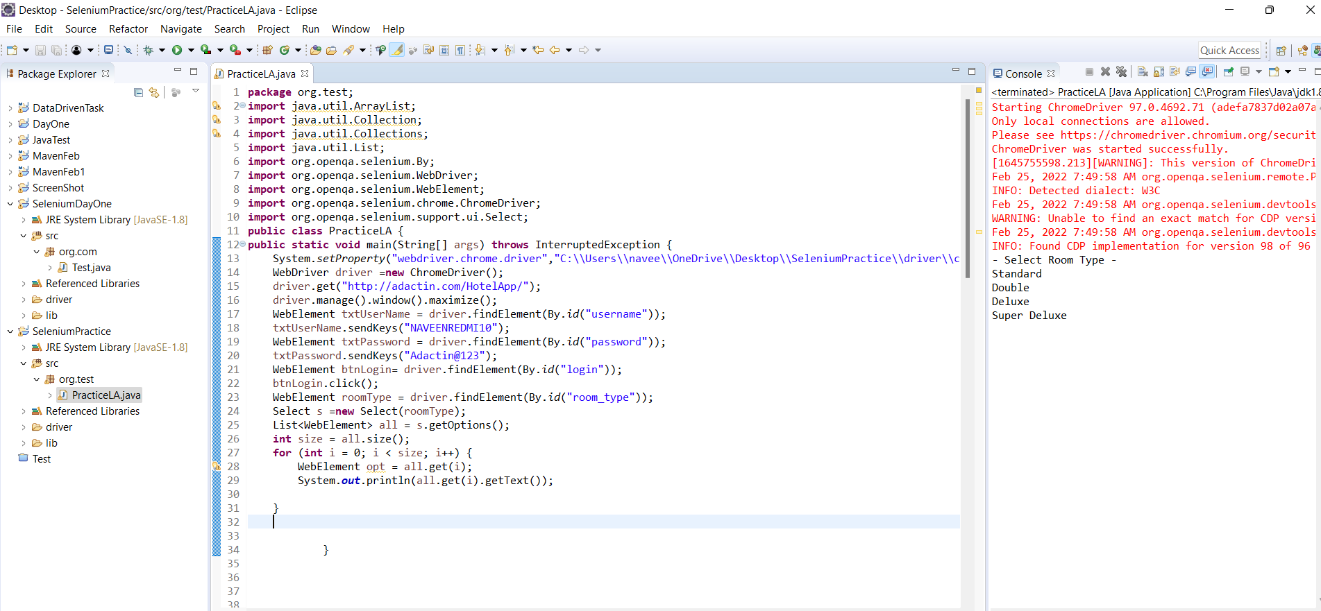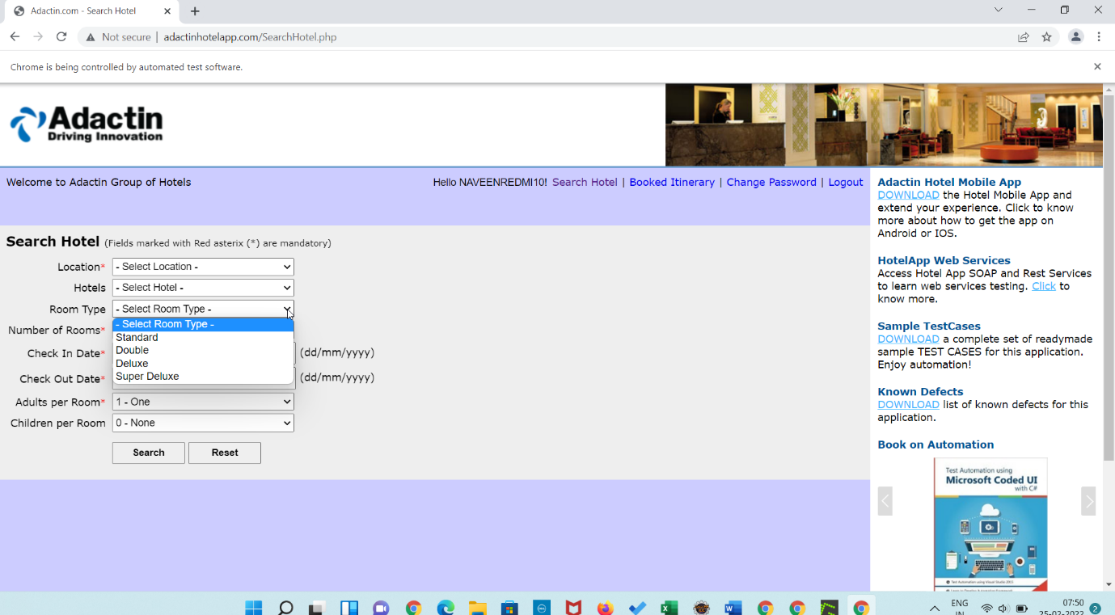

QUESTION 10

-----------

URL : http://adactinhotelapp.com/

NOTE: print all the option in Location available.

**package** org.test;

**import** java.util.ArrayList;

**import** java.util.Collection;

**import** java.util.Collections;

**import** java.util.List;

**import** org.openqa.selenium.By;

**import** org.openqa.selenium.WebDriver;

**import** org.openqa.selenium.WebElement;

**import** org.openqa.selenium.chrome.ChromeDriver;

**import** org.openqa.selenium.support.ui.Select;

**public** **class** PracticeLA {

**public** **static** **void** main(String[] args) **throws** InterruptedException {

System.*setProperty*("webdriver.chrome.driver","C:\\Users\\navee\\OneDrive\\Desktop\\SeleniumPractice\\driver\\chromedriver.exe");

WebDriver driver =**new** ChromeDriver();

driver.get("http://adactin.com/HotelApp/");

driver.manage().window().maximize();

WebElement txtUserName = driver.findElement(By.*id*("username"));

txtUserName.sendKeys("NAVEENREDMI10");

WebElement txtPassword = driver.findElement(By.*id*("password"));

txtPassword.sendKeys("Adactin@123");

WebElement btnLogin= driver.findElement(By.*id*("login"));

btnLogin.click();

WebElement noOfLocation = driver.findElement(By.*id*("location"));

Select s =**new** Select(noOfLocation);

List<WebElement> all = s.getOptions();

**int** size = all.size();

**for** (**int** i = 0; i < size; i++) {

WebElement opt = all.get(i);

System.***out***.println(all.get(i).getText());

}

}

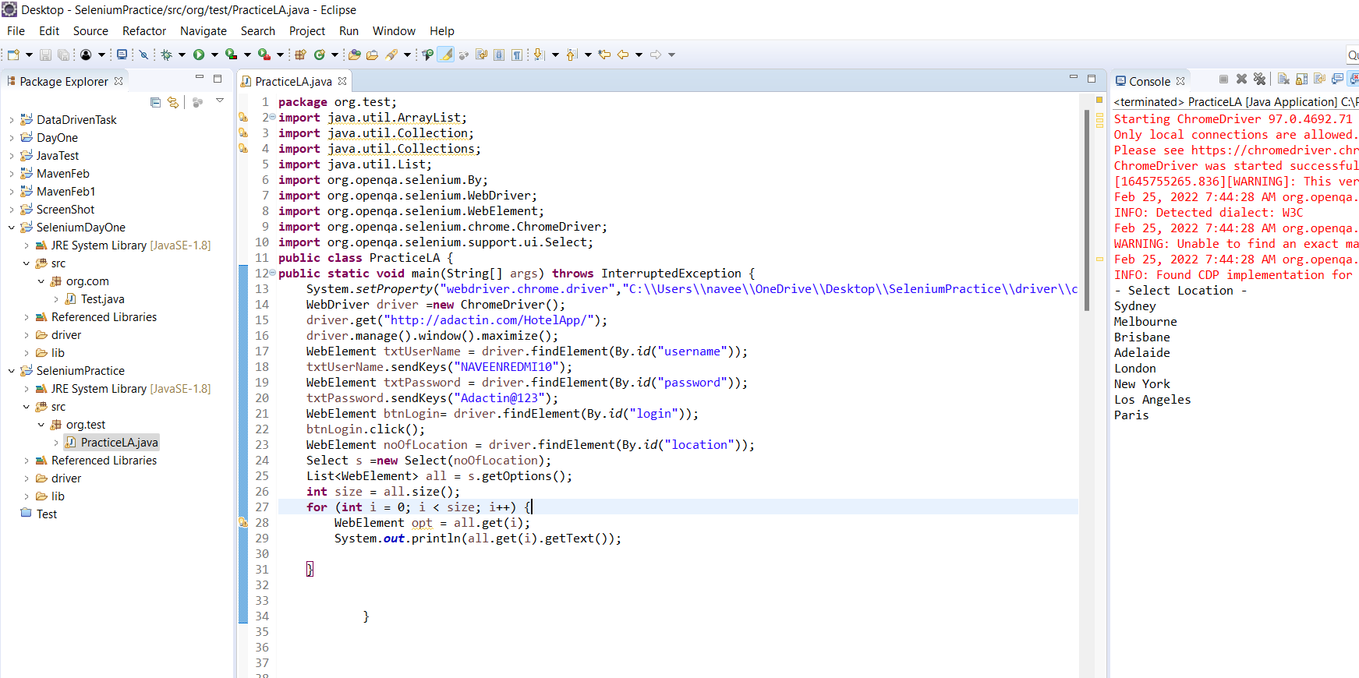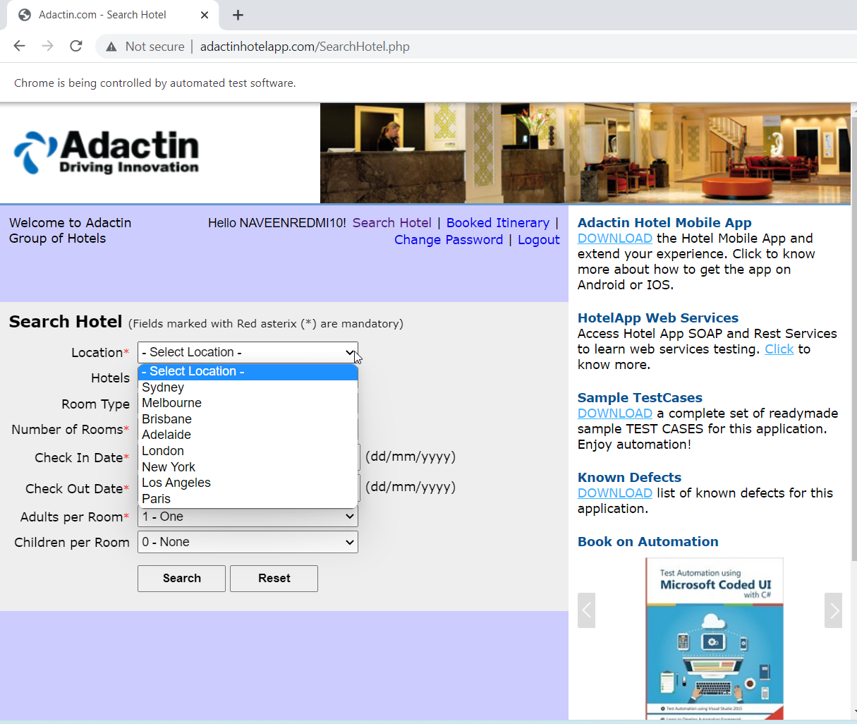

QUESTION 11

-----------

URL : http://adactin.com/HotelApp/

NOTE: print No of option available in Adults per Room

**package** org.test;

**import** java.util.ArrayList;

**import** java.util.Collection;

**import** java.util.Collections;

**import** java.util.List;

**import** org.openqa.selenium.By;

**import** org.openqa.selenium.WebDriver;

**import** org.openqa.selenium.WebElement;

**import** org.openqa.selenium.chrome.ChromeDriver;

**import** org.openqa.selenium.support.ui.Select;

**public** **class** PracticeLA {

**public** **static** **void** main(String[] args) **throws** InterruptedException {

System.*setProperty*("webdriver.chrome.driver","C:\\Users\\navee\\OneDrive\\Desktop\\SeleniumPractice\\driver\\chromedriver.exe");

WebDriver driver =**new** ChromeDriver();

driver.get("http://adactin.com/HotelApp/");

driver.manage().window().maximize();

WebElement txtUserName = driver.findElement(By.*id*("username"));

txtUserName.sendKeys("NAVEENREDMI10");

WebElement txtPassword = driver.findElement(By.*id*("password"));

txtPassword.sendKeys("Adactin@123");

WebElement btnLogin= driver.findElement(By.*id*("login"));

btnLogin.click();

WebElement noOfPersons = driver.findElement(By.*id*("location"));

Select s =**new** Select(noOfPersons);

List<WebElement> all = s.getOptions();

**int** size = all.size();

**for** (**int** i = 0; i < size; i++) {

WebElement opt = all.get(i);

System.***out***.println(all.get(i).getText());

}

}

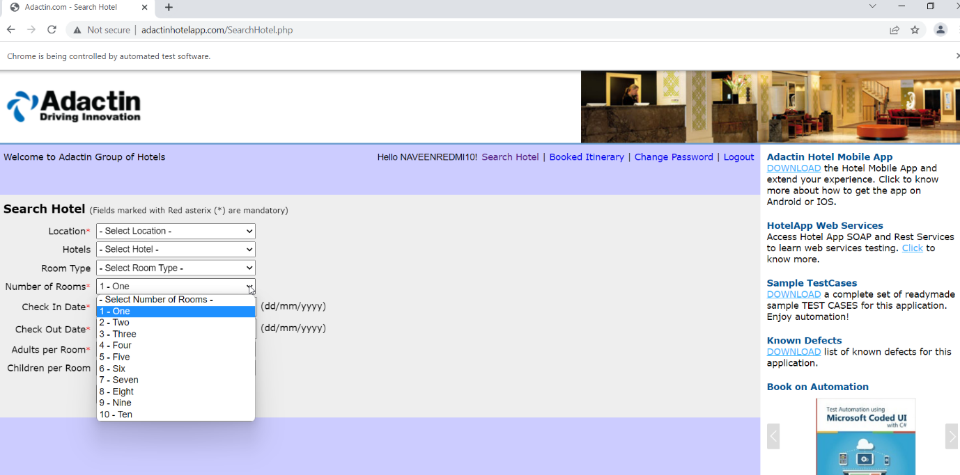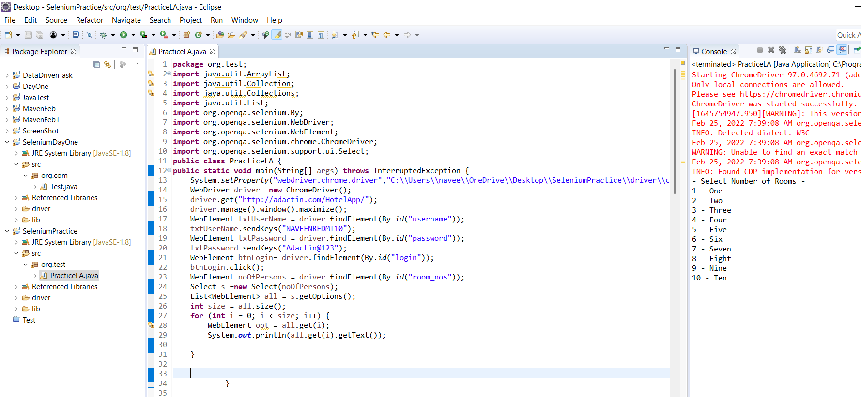

QUESTION 12

-----------

URL : http://output.jsbin.com/osebed/2

NOTE: Select Even Option availble in fruits

Find out number of option not selected

**package** org.hcl;

**import** java.util.List;

**import** org.openqa.selenium.By;

**import** org.openqa.selenium.WebDriver;

**import** org.openqa.selenium.WebElement;

**import** org.openqa.selenium.chrome.ChromeDriver;

**import** org.openqa.selenium.support.ui.Select;

**public** **class** TaskDropdown {

**public** **static** **void** main(String[] args) {

System.*setProperty*("webdriver.chrome.driver", "C:\\Users\\navee\\OneDrive\\Desktop\\March4\\driver\\chromedriver.exe");

WebDriver driver =**new** ChromeDriver();

driver.get("http://output.jsbin.com/osebed/2");

WebElement evenOption= driver.findElement(By.*id*("fruits"));

Select s =**new** Select(evenOption);

List<WebElement> all= s.getOptions();

**int** size = all.size();

System.***out***.println(size);

System.***out***.println("the no of options not selected "+size);

**for**(**int** i=1;i<size;i++) {

**if**(i%2 == 0) {

WebElement opt = all.get(i);

System.***out***.println(all.get(i).getText());

}

}

}

}

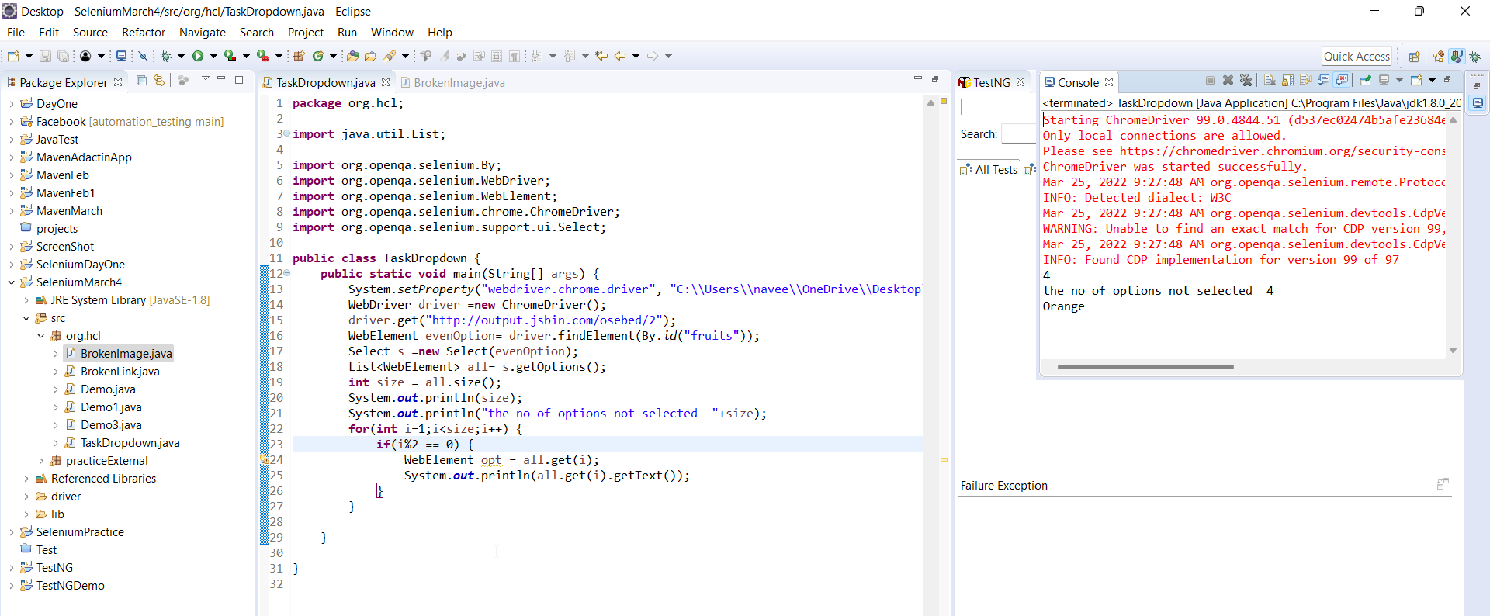

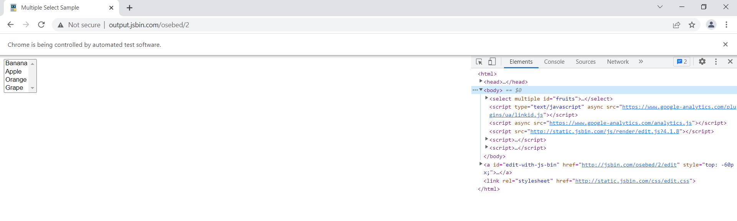

QUESTION 13

-----------

URL : http://output.jsbin.com/osebed/2

NOTE: Select All availble in fruits

Print first selected option